Ruben Pena

MA5781

Homework 1

Exercises - 1.4, 1.5, 1.6, 2.9(a), 2.10, 2.13, 2.14, 2.19,

Libraries: ***TSA***, ***latticeExtra***

**1.4**

Simulate a completely random process of length 48 with independent, chi-square distributed values, each with 2 degrees of freedom. Display the time series plot. **(Ran multiple times, only 2 plots shown)**

R Code

#create time series(as.ts) plots on x/y axis of random chi-square(rchisq) with 48 data points and 2 DOF

xyplot(as.ts(rchisq(48,2)))

xyplot(as.ts(rchisq(48,2)))

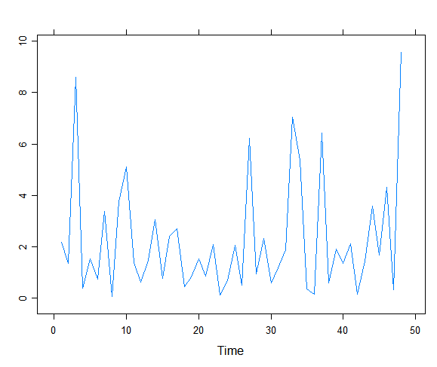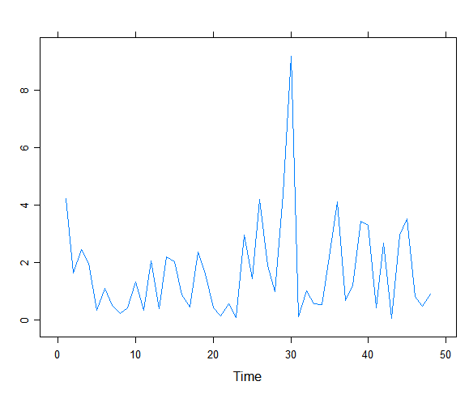

Does it look “random” and non-normal? Repeat this exercise.

Yes, this appears to be random and non-normal.

**1.5**

Simulate a completely random process of length 48 with independent, t-distributed values each with 5 degrees of freedom. Construct the time series plot.  **(Ran multiple times, only 2 plots shown)**

R Code

#create time series(as.ts) plots on x/y axis of random t-distribution(rt) with 48 data points and 5 DOF

xyplot(as.ts(rt(48,5)))

xyplot(as.ts(rt(48,5)))

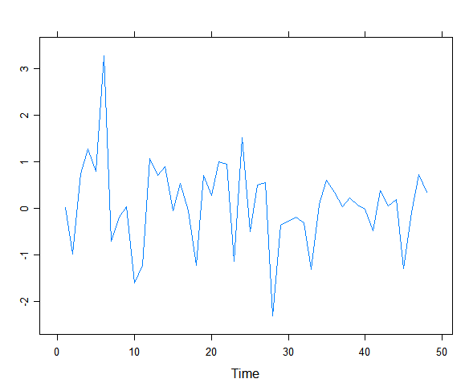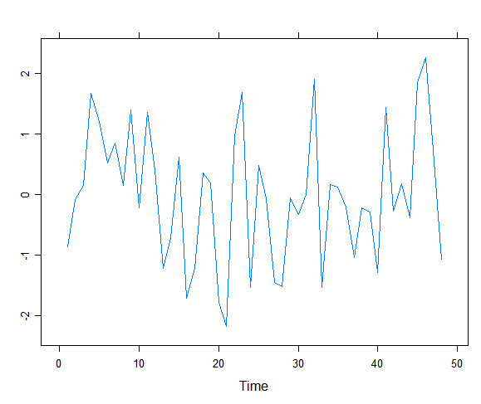

Does it look “random” and non-normal?

This also looks random and appears to be non-normal, but should look normal because it is a t-distribution with n>30.

**1.6**

Construct a time series plot with monthly plotting symbols for the Dubuque temperature series as in Exhibit 1.7, on page 6. The data are in the file named temp-dub.

*R Code*

data(tempdub)

#makes a plot using data “tempdub”. Labels both axes.

xyplot(tempdub, ylab = "Temperature", xlab = "Year")

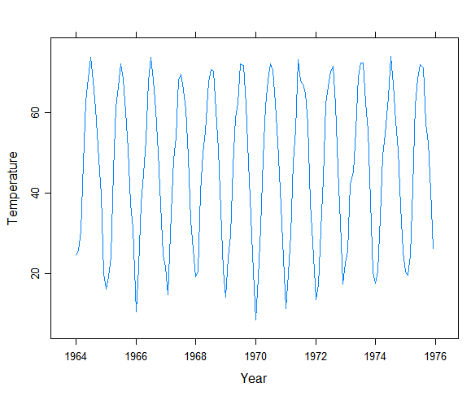

**2.9(a)**

Suppose Yt = β0 + β1t + Xt, where {Xt} is a zero-mean stationary series with autocovariance function γk and β0 and β1 are constants.

***(a)***Show that {Yt} is not stationary but that Wt = ∇Yt= Yt−Yt-1 stationary.

**2.10**

Let {Xt} be a zero-mean, unit-variance stationary process with autocorrelation function ρk. Suppose that μt is a nonconstant function and that σt is a positive-valued non-constant function. The observed series is formed as Yt=μt+σtXt.

***(a)***Find the mean and covariance function for the {Yt} process.

***(b)***Show that the autocorrelation function for the {Yt} process depends only on the time lag. Is the {Yt} process stationary?

***(c)***Is it possible to have a time series with a constant mean and withCorr(Yt,Yt−k) free of t but with {Yt} not stationary?

**2.13**

Let Yt = et−θ(et − 1)2. For this exercise, assume that the white noise series is normally distributed.

***(a)***Find the autocorrelation function for {Yt}.

***(b)***Is {Yt} stationary?

**2.14**

Evaluate the mean and covariance function for each of the following processes. In each case, determine whether or not the process is stationary.

***(a)***Yt = θ0 + tet.

***(b)***Wt = ∇Yt, where Yt is as given in part (a).

***(c)***Yt = etet − 1. (You may assume that{et} is normal white noise.)

**2.19**

Let Y1 = θ0 + e1, and then for t > 1, define Yt recursively by Yt = θ0 + Yt−1 + et. Here θ0 is a constant. The process {Yt} is called a random walk with drift.

***(a)***Show that Yt may be rewritten as Yt = tθ0+et+et-1+...+e1 .

***(b)***Find the mean function for Yt.

***(c)***Find the autocovariance function for Yt.